

APPLICATION
System capacity grant
System Transformation Grant
GPE Multiplier
Girls’ Education Accelerator
June 2024


Contents

The GPE Grant Process 3
Quick Start 4
1. Overview 5
2. System Capacity Grant 6
3. GPE Multiplier 9
4. Girls’ Education Accelerator 9
5. System Transformation Grant 10
6. Partnership Compact 11
7. Program 11
8. Aid Effectiveness 17
9. Results-based Financing 19
10. Grant Agents and Costs 20
11. RISKS AND Safeguards 21
12. Application Development 22
13. Signatures 22
14. Submission 23
Deliverables Checklist 23

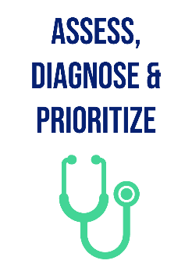
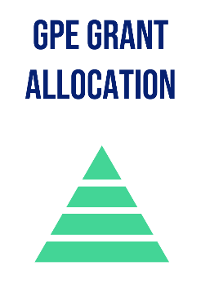

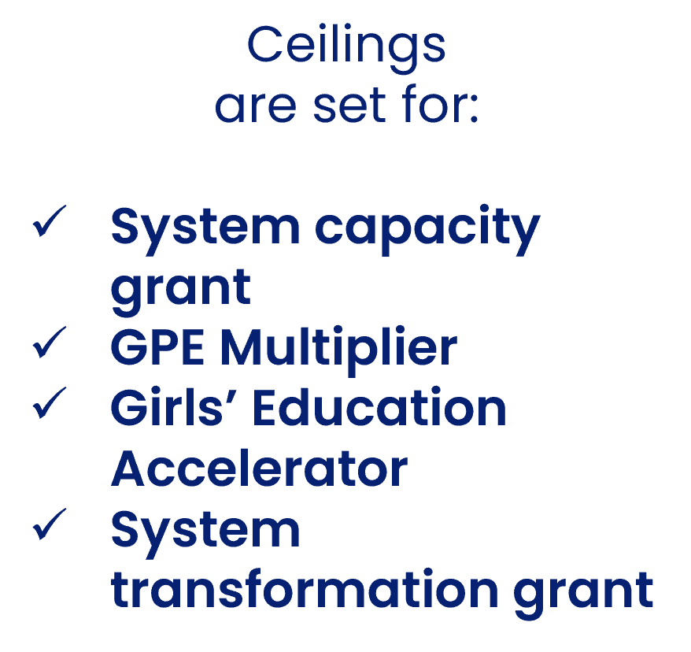
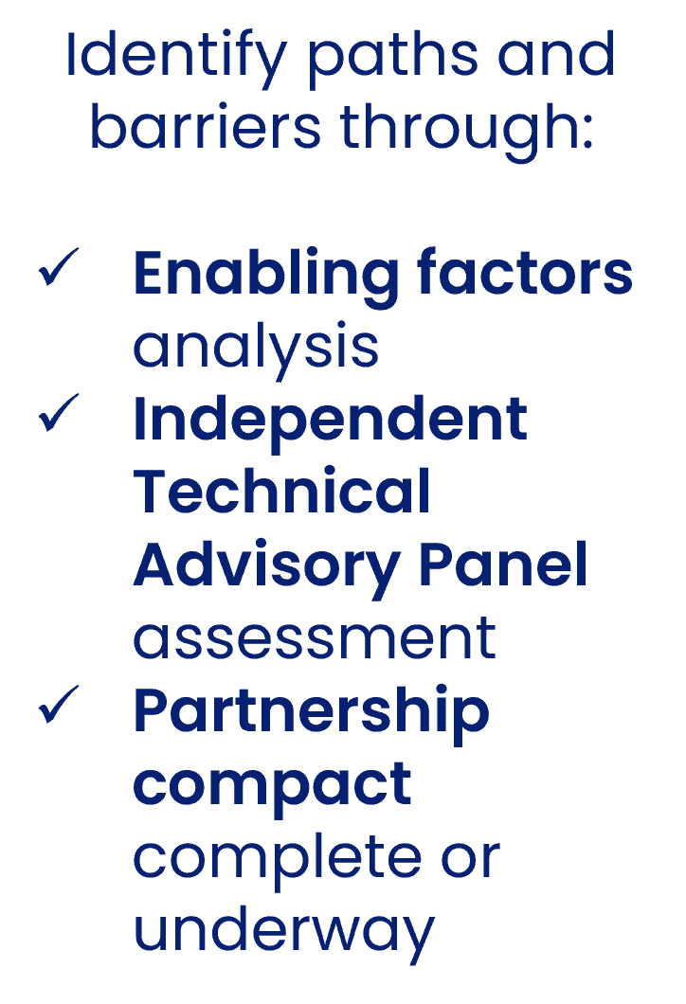
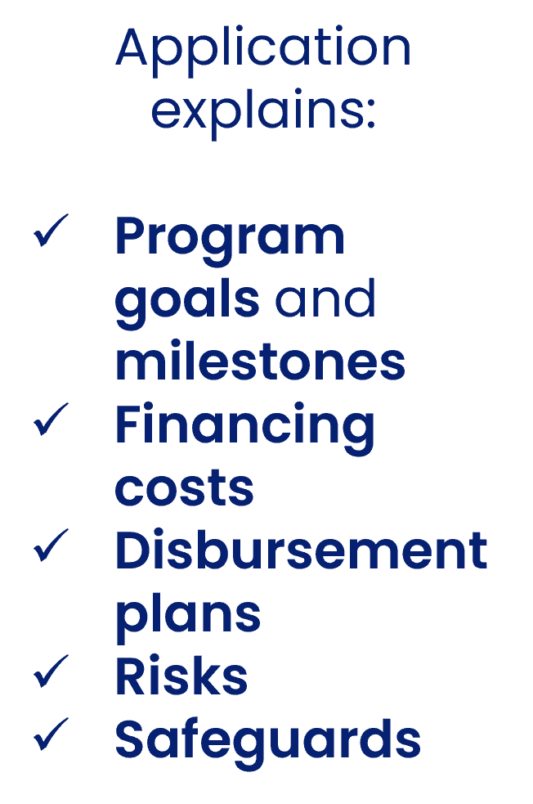


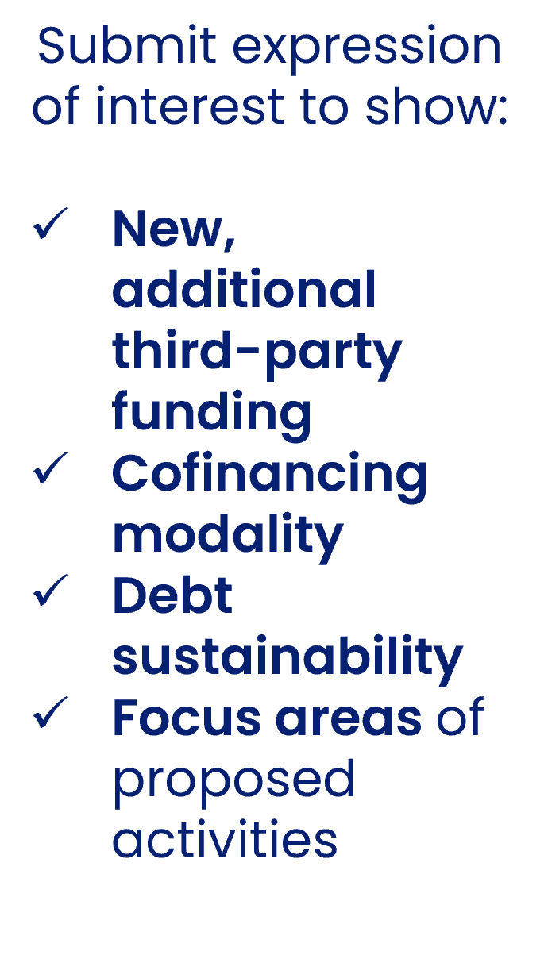
MULTIPLIER ONLY
decision

The GPE Grant Process

Quick Start

What is this document?
Partner countries and their grant agents use this form to apply for GPE’s principal grants:
SYSTEM CAPACITY GRANT
GPE MULTIPLIER
SYSTEM TRANSFORMATION GRANT
GIRLS’ EDUCATION ACCELERATOR
Who is eligible and for how much?
Eligibilities and grant ceilings for each partner country are available via the GPE website.
What do I need to do?
The system capacity grant can be accessed at any time for a broad range of capacity building activities, but it is ideally suited for those countries seeking to address weaknesses identified during the enabling factors analysis, the first step in the diagnostic and planning phases that typically precede GPE funding.
Countries applying for the other three grants most likely have already completed the enabling factors analysis and the Independent Technical Advisory Panel (ITAP) assessment in developing their partnership compact. Those applying for the GPE Multiplier must also have confirmed their potential grant amount via an expression of interest, reviewed and approved by the GPE Secretariat.

See the system capacity grant guidelines, Multiplier guidelines or system transformation grant in completing this form. Depending on the grant or combination of grants you are applying for, you will be asked to complete specific sections of this form and omit others. If combining a system capacity grant with other grants, the country can choose to submit a combined program document and budget.
What do I provide?
You can insert as annexes to this application those documents that support your answers as specified. You can review the checklist at the conclusion of this application for all the required deliverables. The coordinating agency submits the final application on behalf of the government and the local education group, copying the grant agent, relevant government officials (including the education ministry), as well as the GPE focal point and Secretariat country team lead. Email submissions to gpe_grant_submission@globalpartnership.org
What’s next?
The Secretariat conducts its final quality assurance review and prepares the necessary documentation for the final decision by the GPE Board or chief executive officer. This is relayed to the government, grant agent and coordinating agency within 10 business days of the decision.
Transparency
GPE’s transparency policy requires that all approved grant applications and other related documents are posted to the country pages of GPE’s website. Personal or sensitive information, including phone numbers and email addresses, will be removed before publication.

Overview
GENERAL INFORMATION (ALL GRANTS)
Country: | Click here to enter text.
Coordinating agency: | Click here to enter text.
Date of submission of the full application package: | Click here to enter a date.
Grant currency:  (The grant agent makes the currency selection in consultation with the government and the local education group. See grant guidelines for further details) | Dollar ☐ Euro ☐
SPECIFIC INFORMATION FOR:
- SYSTEM TRANSFORMATION GRANT
- GPE MULTIPLER
- GIRLS’ EDUCATION ACCELERATOR
(If applying ONLY for a SYSTEM CAPACITY GRANT, please proceed to SECTION 2)
Program name: | Click here to enter text.
Total grant amount requested:  (Includes implementation costs such as grant agent direct costs. For details, see Section 10) | Click here to enter amount.
Will results-based programming be used to implement any part of the grant amount requested? | Yes ☐ No ☐
If YES, provide amount and percentage of total grant that will be programmed as results-based financing: | Click to enter amount and percentage.
Grant agent: | Click here to enter text.
Agency fees (additional to grant allocation; list agencies and corresponding fees if there are multiple grant agents): | Click here to enter amount.
Other donor financing for the program, including cofinancing for the GPE Multiplier (list donors and amount): | Click here to enter text.
Estimated starting date: | Click here to enter a date.
Estimated closing date:  (last day of the month, e.g., June 30, 2025) | Click here to enter a date.
REQUESTED GRANT AMOUNTS
System transformation grant: | Click here to enter amount.
GPE Multiplier: | Click here to enter amount.
Multiplier cofinancing mobilized from others: | Click here to enter amount.
Girls’ Education Accelerator: | Click here to enter amount.

System Capacity Grant
About
The system capacity grant can be used to fund activities necessary to ensure the success of subsequent reforms and programs, including development of a country’s partnership compact. Refer to the system capacity grant guidelines in preparing this application.
NOTE: If the system capacity grant is to be combined with other GPE grants, the country can choose to integrate information into a single program document and budget, as long as it specifies the activities that will be financed through the system capacity grant.
Period of the next education sector plan/transitional plan  (if applicable): | Click here to enter time period.
Maximum system capacity grant allocation: | Click here to enter amount.
Total system capacity grant amount requested, across all three windows: | Click here to enter amount.
Is this amount additional funding for an existing system capacity grant implemented by the same grant agent? | Yes ☐ No ☐
Agency fees (additional to grant allocation; list agencies and corresponding fees if there are multiple grant agents): | Click here to enter agents and amounts.
Total and sources of funding for activities supported by system capacity grant (list amount per source of funding): | Click here to enter amount and source.
Financing window 1: Strengthen gender-responsive planning and policy development for systemwide impact
Grant agent(s): | Click here to enter text.
Amount requested for window 1: | Click here to enter amount.
Estimated starting date: | Click here to enter a date.
Estimated completion date: | Click here to enter a date.
Financing window 2: Mobilize coordinated action and financing to enable transformative change
Grant agent(s): | Click here to enter text.
Amount requested for window 2: | Click here to enter amount.
Estimated starting date: | Click here to enter a date.
Estimated completion date: | Click here to enter a date.
Financing window 3: Strengthen capacity, adapt and learn, to implement and drive results at scale
Grant agent(s): | Click here to enter text.
Amount requested for window 3: | Click here to enter amount.
Estimated starting date: | Click here to enter a date.
Estimated completion date: | Click here to enter a date.
Estimated date for system transformation grant/Multiplier submission, if relevant: | Click here to enter a date.

Financing Windows
Check the boxes for the relevant activities for which funding is being requested
Financing window 1:
Strengthen gender-responsive planning and policy development for systemwide impact
- System diagnostics, partnership compact development and education sector analysis |  | ☐
- Gender-responsive sector planning, including operational planning and budgeting |  | ☐
- Supporting policies and plans to identify and address multiple forms of exclusion and strengthen system resilience (including planning for children with disabilities and inclusion of displaced children) |  | ☐
- Strengthening evidence-based diagnosis of critical implementation bottlenecks and identifying potentially scalable, transformative solutions |  | ☐
Financing window 2:
Mobilize coordinated action and financing to enable transformative change
- Strengthening sector coordination, including local education groups, joint sector reviews and monitoring the effectiveness of the country-level partnership |  | ☐
- Establishing and operating pooled funding mechanisms |  | ☐
- Strengthening budget processes and ministry of finance engagement; identifying opportunities to improve the equity and efficiency of education expenditure, including processes toward gender equality |  | ☐
- Cross-sectoral convening |  | ☐
Financing window 3:
Strengthen capacity, adapt and learn, to implement and drive results at scale
- Strengthening data systems, including on improving the availability and use of sex-disaggregated data, and data on children with disabilities |  | ☐
- Training, capacity building and support for government staff at central and decentralized levels, including on the uptake and use of data and evidence |  | ☐
- Support for implementation capacity, including sector plan implementation monitoring, gender responsiveness of the sector and evaluation of sector plans and policies/programs in priority areas; assess monitoring, evaluation and learning capacity, including use of evidence in the policy process |  | ☐
Linking Activities with Enabling Factors Analysis and Partnership Compact
Does the country already have an endorsed partnership compact? | Yes ☐ No ☐
Will this funding support enabling factors analysis or development of a compact? | Yes ☐ No ☐
Will this funding support activities related to the needs identified in the compact? | Yes ☐ No ☐
If NOT eligible for a system transformation grant, please answer the next two questions
Has the country conducted an enabling factors analysis? | Yes ☐ No ☐
If answering yes to previous question, will this funding support activities identified in the enabling factors analysis? | Yes ☐ No ☐

Program Proposal
DELIVERABLE: The complete system capacity grant application should include as an attachment a program proposal, which defines the scope of the work and associated tasks. If the proposed program is not specifically focused on capacity strengthening as regards gender equality, it should still draw on a gender-equality perspective in the design of program activities. The program design should also include the identification of risks associated with sexual exploitation, abuse, and harassment (SEAH) that may be induced or exacerbated by the system capacity grant. The proposal is prepared in a separate Word document and based on the system capacity grant guidelines.
Please ensure that the program proposal clearly outlines how the grant will resolve the system capacity gaps identified during the enabling factors analysis. If this information is not included in the document, please explain here. Provide any comments on the document to be attached, if necessary.
Click here to enter text.
Budget
DELIVERABLE: The complete application should include the budget and timeline for the activities for which GPE funding is requested, using the system capacity grant Excel template.
Please provide any comments on the attached budget template, if needed.
Click here to enter text.
Endorsement
DELIVERABLE: The complete application should include the minutes of the local education group meeting during which the system capacity grant application was endorsed.
Before the application is sent to the Secretariat, it should be endorsed by the local education group to ensure consensus around the activities to be supported and that all members of the group are properly informed. Please provide any comments, if needed.
Click here to enter text.
IF APPLYING FOR A SYSTEM CAPACITY GRANT ONLY, CLICK HERE TO GO TO SECTION 11

GPE Multiplier
About
The GPE Multiplier mobilizes external funding alongside a contribution from GPE. Approval requires that total cofinancing that meets the US$3-to-US$1 ratio required when the funding is sourced from development partners or US$1-to-US$1 ratio for private sector or foundation contributions.
Please provide the name of each cofinancing partner, the amount and the instrument, such as grant, loan, etc. The amount of funding should equal or exceed the value of cofinancing included in the expression of interest. If it does not, please explain the variation.
# |  | Partner | Amount (US$) |  | Instrument (grant, loan, etc.)
1 | Click here to enter text. |  | Enter amount. | Click here to enter text.
2 | Click here to enter text. |  | Enter amount. | Click here to enter text.
3 | Click here to enter text. |  | Enter amount. | Click here to enter text.
4 | Click here to enter text. |  | Enter amount. | Click here to enter text.
 | Total in US$: |  | Enter amount. | Click here to enter text.
Enter text here to explain if cofinancing amount lower than in expression of interest.

If not applying for a girls’ education accelerator, CLICK HERE TO GO TO SECTION 6

Girls’ Education Accelerator
About
An eligible partner country can request dedicated funding from the Girls’ Education Accelerator when applying for a GPE Multiplier and/or system transformation grant.
If applying for a Girls’ Education Accelerator grant as part of a GPE Multiplier or system transformation grant, please specify the page numbers in the relevant program document(s) that explains how the program component(s) financed by the Accelerator will contribute to advancing girls’ education and strengthen the overall GPE grant contribution to progressing gender equality. | Click to enter page numbers.
If there are separate grant agents for the Girls’ Education Accelerator grant and the GPE Multiplier or system transformation grant, please explain how the programs will work together towards the achievement of shared results.
Click here to enter text.
Contribution to the Girls’ Education Accelerator core indicators (Complete ONLY if the project or program document is requesting dedicated funding from the Girls’ Education Accelerator).

In demonstrating a commitment to results, a country accessing the Girls’ Education Accelerator should include at least one of a set of core indicators in the results framework as appropriate. Indicate any relevant core indicator for this application below. Please disaggregate data by sex as appropriate.
Indicate if using calendar or implementation year: |  |  |  |  |  | Calendar Year ☐ Implementation Year ☐
Target outputs/outcomes per year (non-cumulative)
 | Baseline (Year 0) | Year 1 | Year 2 | Year 3 | Year 4 |  | Year 5 | Total | % GPE contribution (optional for cofinanced grants)
Core indicator: | Enter here | Enter here | Enter here | Enter here | Enter here |  | Enter here | Enter here | Enter here
Core indicator: | Enter here | Enter here | Enter here | Enter here | Enter here |  | Enter here | Enter here | Enter here
Core indicator: | Enter here | Enter here | Enter here | Enter here | Enter here |  | Enter here | Enter here | Enter here
If not applying for a system transformation grant, click here to go to section 6

System Transformation Grant
About
Partner countries can receive up to US$162.5 million through a system transformation grant to finance priority programs that will overcome stubborn bottlenecks in the education sector and deliver change at scale. Each country specifies a priority reform to be supported by GPE resources in its partnership compact and then outlines relevant education programs and key objectives in this application.
Please refer to the system transformation grant guidelines for assistance in completing the following sections of this form.

Partnership Compact
Does the country have a partnership compact? (If yes, please proceed to Section 7) | Yes ☐ No ☐
Does the country plan to develop a compact? | Yes ☐ No ☐
If planning is underway to develop a compact, when is the expected delivery date? | Enter date.
If applying for a Multiplier only and in the absence of a compact, briefly describe:
- the evidence base or policy document that informs the program for which this funding is being requested
- how you intend to address the high priority areas identified in the enabling factors analysis.
Provide as an annex all relevant documents.
Click here to enter text.

Program
Please provide information on the program components or objectives by source of funding.

If seeking a Girls’ Education Accelerator in this application, indicate the specific components it will target.
Program component/ objectives | GPE contributions from system transformation grant, Multiplier, Girls’ Education Accelerator (GEA) |  | Other donor contributions  (US$)
 | Amount (US$) per component | Focused on girls’ education
- Click here to enter text. | Enter amount | Amount from GEA in US$  Enter specific activities | Enter donor name  Amount in US$
- Click here to enter text. | Enter amount | Amount from GEA in US$  Enter specific activities | Enter donor name  Amount in US$
- Click here to enter text. | Enter amount | Amount from GEA in US$  Enter specific activities | Enter donor name  Amount in US$
- Click here to enter text. | Enter amount | Amount from GEA in US$  Enter specific activities | Enter donor name  Amount in US$
- Click here to enter text. | Enter amount | Amount from GEA in US$  Enter specific activities | Enter donor name  Amount in US$

Program description
Specify the page numbers in the program document that describe the program. It should include information on program objectives and expected outcomes, and—in the case of grants implemented by project modalities—the components and subcomponents, with related financing amounts.
OR:
In up to 1,500 words, please provide a summary that describes the program’s objectives and related expected outcomes, and the components and subcomponents with their financing amounts.
If this is a cofinanced project, indicate, where relevant, GPE’s anticipated share by components and subcomponents.
For sector-pooled funds and budget support programs where the initial earmarking of resources by inputs, activities, components and subcomponents (typical of project modalities) may not be relevant, please outline the key elements from the program document.
Click here to enter text.
Programming indicative allocation with a top-up
- Was GPE Board approval of the strategic parameters and indicative allocation conditioned on a portion of the allocation (i.e., the “top-up”) being withheld until achievement of agreed triggers? | Yes ☐  No ☐
- Is this application seeking access to 100% of the indicative allocation approved by the Board? | Yes ☐  No ☐
If responding YES to both questions immediately above, explain the potential adjustments that will be made to the program should achievement fall short of the agreed triggers, leading to withholding of the top-up allocation.

Click here to enter text.

System transformation
Specify the relevant page numbers in the program document that contain a description of how the program will contribute to system transformation.
OR:
In no more than 600 words, provide a summary of how the program will contribute to system transformation.
Click here to enter text.
Gender
GPE expects that activities to address gender inequalities are identified in all grants, with the Partnership Compact setting out how gender equality will be advanced within the chosen priority reform area. Summarize below how the program supports the priorities identified on gender equality (based on available data and analysis) and include how gender has been considered within each component.
Click here to enter text.
Support to education providers
- Will the program provide resources to support private for-profit schools? | Yes ☐ No ☐
- Will the program provide resources to support not-for-profit non-state providers of core education services? | Yes ☐ No ☐
- If the program plans to support not-for-profit, non-state providers of core education services (such as community-owned and faith-based schools), is there a government regulatory framework? | Yes ☐ No ☐
- If there is no regulatory framework (or if the existing one is insufficient), does the program help establish a regulatory framework, or is there other financing available to support the development of a regulatory framework?  Please provide any additional clarification below. | Yes ☐ No ☐

Click here to enter text.
Disability inclusion: Describe how each program component will include children with disabilities. If disability inclusion is not relevant for any component, leave the box blank and explain below.
Program component | Brief description of how the component will include children with disabilities.
- Click here to enter text. | Click here to enter text.
- Click here to enter text. | Click here to enter text.
- Click here to enter text. | Click here to enter text.
- Click here to enter text. | Click here to enter text.
- Click here to enter text. | Click here to enter text.
If you have omitted a description of how any of the components above will include children with disabilities, please explain why disability inclusion is not relevant for the component(s). Please briefly explain whether this is consistent with international commitments in relation to disability inclusion made by the government or its grant agent.
Click here to enter text.
Start date
It is expected that the program starts within 6 months of GPE grant approval. If the program starts later than indicated here, a request for a late start date needs to be submitted to the GPE Secretariat.
When is the program expected to commence implementation?
Click here to enter text.
Commencement
Please define the event or activity that will mark the start of the program and that will take place by the expected start date. For some grant agents, this definition has been agreed with their headquarters.
(For example, for Agence Française de Développement, the program starts at the signing of the grant agreement. For the World Bank, it is marked by grant effectiveness. For UNICEF, CARE, and Save the Children, it is assumed that program implementation commences on the indicated start date unless the Secretariat is notified otherwise.)
Click here to enter text.
Outputs for reporting purposes
(Complete ONLY if the project or program document plans to purchase textbooks, train teachers or build/rehabilitate classrooms).
Please provide the proposed numbers of textbooks to be purchased and distributed, teachers to be trained (including head teachers) and classrooms that will be built or rehabilitated. Relevant indicators should be included in the full results framework linked to the program document and in the progress and completion reports. Provide targets for each year rather than cumulative values.
If the grant is cofinanced or project-pooled, enter the numbers for the entire project or program and the estimated percentage that is attributed to GPE funding in the final column below.
For sector-pooled funds and budget support programs, indicate numbers planned at sector level. Replace Year 1, Year 2, etc. with the actual year (for example, 2024, 2025, and so on). Annual targets are noncumulative. If the grant modality is sector-pooled funds or budget support, please enter the estimated percentage that is attributed to GPE funding in the final column below. In all cases, please disaggregate number of teachers by sex.

Indicate if using calendar or implementation year: |  |  |  |  | Calendar Year ☐ Implementation Year ☐
Target outputs per year (not cumulative)
 | Baseline (Year 0) | Year 1 | Year 2 | Year 3 |  | Year 4 | Year 5 | Total |  | % GPE contribution (optional)
Number of textbooks purchased, distributed: | Enter number | Enter number | Enter number | Enter number |  | Enter number | Enter number | Enter number |  | Enter number
Number of teachers trained: | Total:  Enter number | Total:  Enter number | Total:  Enter number | Total:  Enter number |  | Total:  Enter number | Total:  Enter number | Total:  Enter number |  | Total:  Enter number
 | Female:  Enter number | Female:  Enter number | Female:  Enter number | Female:  Enter number |  | Female:  Enter number | Female:  Enter number | Female:  Enter number |  | Female:  Enter number
 | Male: Enter number | Male: Enter number | Male: Enter number | Male: Enter number |  | Male: Enter number | Male: Enter number | Male: Enter number |  | Male:  Enter number
Number of classrooms built or rehabilitated: | Enter number | Enter number | Enter number | Enter number |  | Enter number | Enter number | Enter number |  | Enter number
Number of children expected to directly benefit from the program
Please provide the number of children (both in school and out of school) who will directly benefit from the programs or activities supported by the grant, including incentives or services and interventions receiving grant funds. Also provide relevant disaggregated numbers by sex (applicable to all grants).
If appropriate and available, provide disaggregated values by subgroups and by education level. It is understood that some disaggregated data will only be provided if a project expressly targets specific subgroups through their interventions and uses their own methods for counting beneficiary children.
If the grant is cofinanced, enter the numbers for the entire project. Please also provide disaggregated numbers by sex for subgroups in the table below.
The “Other” category encompasses students beyond school age (pre-primary through secondary) who are not already included: e.g., out-of-school adolescents and adult learners in non-formal education.
 |  |  |  | Pre-primary | Primary | Secondary | Other | Total
 |  | Total children who will directly benefit from the grant: |  | Total:  Enter number | Total:  Enter number | Total:  Enter number | Total:  Enter number | Total:  Enter number
 |  |  |  | Female:  Enter number | Female:  Enter number | Female:  Enter number | Female:  Enter number | Female:  Enter number
 |  |  |  | Male:  Enter number | Male:  Enter number | Male:  Enter number | Male:  Enter number | Male:  Enter number
 |  | Children with a disability:  (if applicable) |  | Total:  Enter number | Total:  Enter number | Total:  Enter number | Total:  Enter number | Total:  Enter number
 |  |  |  | Female:  Enter number | Female:  Enter number | Female:  Enter number | Female:  Enter number | Female:  Enter number
 |  |  |  | Male:  Enter number | Male:  Enter number | Male:  Enter number | Male:  Enter number | Male:  Enter number
 |  | Refugee children:  (if applicable) |  | Total:  Enter number | Total:  Enter number | Total:  Enter number | Total:  Enter number | Total:  Enter number
 |  |  |  | Female:  Enter number | Female:  Enter number | Female:  Enter number | Female:  Enter number | Female:  Enter number
 |  |  |  | Male:  Enter number | Male:  Enter number | Male:  Enter number | Male:  Enter number | Male:  Enter number
 |  | Internally displaced children:  (if applicable) |  | Enter number | Enter number | Enter number | Enter number | Enter number
 |  |  |  | Female:  Enter number | Female:  Enter number | Female:  Enter number | Female:  Enter number | Female:  Enter number
 |  |  |  | Male:  Enter number | Male:  Enter number | Male:  Enter number | Male:  Enter number | Male:  Enter number
 |  | Out-of-school children:  (if applicable) |  | Enter number | Enter number | Enter number | Enter number | Enter number
 |  |  |  | Female:  Enter number | Female:  Enter number | Female:  Enter number | Female:  Enter number | Female:  Enter number
 |  |  |  | Male:  Enter number | Male:  Enter number | Male:  Enter number | Male:  Enter number | Male:  Enter number
 |  | Children from marginalized ethno-cultural/linguistic minorities:  (if applicable; please specify) |  | Enter number | Enter number | Enter number | Enter number | Enter number
 |  |  |  | Female:  Enter number | Female:  Enter number | Female:  Enter number | Female:  Enter number | Female:  Enter number
 |  |  |  | Male:  Enter number | Male:  Enter number | Male:  Enter number | Male:  Enter number | Male:  Enter number
 |  |  | Provide any comments on beneficiary children, if needed. This could include, for example, the definition employed by the grant for a particular subgroup (including a more granular description of these subgroups), the approach or tool used to calculate the number of beneficiaries overall or by subgroup, any limitation of the approach or tool employed for this calculation and reasons why data on beneficiary children are unavailable.
 | Click here to enter text.

Describe how any data gaps will be addressed so that sex-disaggregated data across all categories can be included in grant monitoring.
Click here to enter text.

Program financial overview
Provide the location (page numbers) in the program document where a description of the grant implementation arrangements can be found.
Click here to enter text.
Utilization of the GPE grant should be prioritized in comparison with other sources of funding, including those from the grant agent. If for any reason, the GPE grant cannot be prioritized, please explain below. Request for extension of GPE grants may not be approved if other sources of funding have been prioritized without prior agreement.
Click here to enter text.
Please indicate program disbursement by year as applicable, based on information extracted from the program document. If it is a cofinanced modality, indicate estimates for the expected disbursements of GPE funds by year. For these purposes, the implementation year begins at the grant effectiveness/signing of grant agreement.

For example, if the start date or grant signing is expected to occur in July 2023, then the implementation year is July 2023 to June 2024, and July 2023 is entered as “Year 1”. The program costs per calendar year for 2023 should reflect the estimated costs for the July–December 2023 period.

Expected disbursements by year
Indicate years (e.g., 2023): |  |  | Year 1 |  | Year 2 |  | Year 3 |  | Year 4 |  | Year 5 |  | Total
Total program disbursements per implementation year: |  |  | Enter here |  | Enter here |  | Enter here |  | Enter here |  | Enter here |  | Enter here
Total program disbursements per calendar year: |  |  | Enter here |  | Enter here |  | Enter here |  | Enter here |  | Enter here |  | Enter here
Program costs and expected disbursements by component
If NOT using budget support as the grant modality, please complete the table below, listing the proposed interventions or components and indicating the expected disbursement by year (e.g., 2024), total cost in US dollars per component and their respective percentage of the total grant.
If it is a cofinanced program, indicate estimates for the expected disbursements of GPE funds by year.
(You can extend and adapt the table to the number of components that fits the program, by adding rows if needed.)
Components/  objectives | Year 1 | Year 2 |  | Year 3 |  | Year 4 |  | Year 5 |  | Total |  | %
Enter text here | Enter here | Enter here |  | Enter here |  | Enter here |  | Enter here |  | Enter here |  | Enter here
Enter text here | Enter here | Enter here |  | Enter here |  | Enter here |  | Enter here |  | Enter here |  | Enter here
Enter text here | Enter here | Enter here |  | Enter here |  | Enter here |  | Enter here |  | Enter here |  | Enter here

Aid Effectiveness
Grant financing modality
Please briefly explain how the proposed grant financing modality is evolving in comparison to the previous grant (where applicable) as regards alignment with national systems.
 |  | Previous GPE grant (indicate amount and program name) | Current application
In relation to the education sector plan
Are resources from the GPE co-funded program shown in education sector’s annual, budgeted operational plan? |  | Click here to enter text. | Click here to enter text.
Are the projected expenditures of the program included in the multiyear forecast of the ministry of finance (medium-term expenditure framework)? |  | Click here to enter text. | Click here to enter text.
In relation to harmonization
Does the grant financing modality operate as a joint financing mechanism, combining several fungible donor sources? Briefly explain (indicating participating donors). | Click here to enter text. |  |  | Click here to enter text.

In relation to the national budget and parliament
Is the GPE-funded program clearly indicated in the national budget or annual finance law? | Click here to enter text. | Click here to enter text.
Does the national annual budget show specific appropriations for the different planned expenditures (economic or functional classification)? Is program funding reflected in the budget by area of allocation and planned utilization, using the existing national classification? | Click here to enter text. | Click here to enter text.
In relation to treasury
Is the majority of the financing disbursed into:  (a) the main revenue account of government,  (b) a specific account at treasury, or  (c) a specific account at a commercial bank? | Choose an item. | Choose an item.
Is the expenditure process (documents and signatures on commitment, payment orders, etc.) for the national budget used for the program expenditures? | Click here to enter text. | Click here to enter text.
Are there any specific derogations or safeguards on the national execution procedures for the program expenditures (i.e., other documents or signatures)? | Click here to enter text. | Click here to enter text.
In relation to procurement
Are government procurement rules and institutional accountabilities used? If so, are there any derogations or safeguards on the use of these rules? | Click here to enter text. | Click here to enter text.
In relation to accounting
Is the financial accounting directly on government accounting systems used for the national budget? If not, are the accounting results afterward integrated in government’s accounting systems? | Click here to enter text. | Click here to enter text.

In relation to audit
Will the financial accounts be audited by the government’s external auditor (e.g., by any court of auditors or national audit office that is external to the government’s general finance inspectorate of the ministry of finance)? | Click here to enter text. | Click here to enter text.
Please specify who audits the accounts of the financing modality funded or co-funded with the GPE grant. | Click here to enter text. | Click here to enter text.
In relation to reporting
Will the information on program execution be included in an education sector plan annual implementation report, prepared by the ministry of education? | Click here to enter text. | Click here to enter text.
Will separate or additional reports be required for the program? | Click here to enter text. | Click here to enter text.
Evolution of aligned assistance
In 375 words or less, please describe how the proposed grant financing modality is evolving in comparison with the previous grant (if applicable) based on the responses in this table. Include what mechanisms are in place to mitigate fiduciary risks and why they seem appropriate and detail how the proposed program sets a foundation for more aligned assistance in the future.
Click here to enter text.

Results-based Financing
Well-designed results-based financing can incentivize change while emphasizing accountability throughout program development and implementation. A focus on results over expenditures also encourages greater alignment of funding with national systems.
Results-based financing components aligned with grant agent procedures are expected to be included within GPE grants. If, as noted in the Overview at the beginning of this document, results-based financing is NOT included in this grant, please explain this decision in the space below (maximum 600 words):
Click here to enter text.

If the grant includes results-based financing, briefly describe these components, including disbursement-linked indicators and results, target dates, linked amounts and triggers.

OR
Specify the pages of the program document that contain a description of the results-based components, including disbursement-linked indicators and results, target dates, linked amounts and triggers.
Click here to enter text.

Grant Agents and Costs
In less than 400 words, describe in the box below the internal procedures and processes of the grant agent in relation to the administration and monitoring of this grant, as well as its added value as far as technical, financial or other strengths.
Click here to enter text.
Grant agent roles
Please describe the specific roles the grant agent(s) will perform in the implementation and/or oversight of the grant, including action that can be taken to resolve Implementation issues.
Click here to enter text.
Grant evaluation  Does the grant agent plan to conduct an evaluation of any activities funded through this grant? | ☐ No  ☐ Yes  If yes, provide in no more than 300 words a brief description of the activities that will be evaluated and the completion date for the evaluation.
Click here to enter text.

Program implementation costs (other grant agent costs and general agency fees, US$)
Indicate years (e.g., 2024) | Year 1 | Year 2 | Year 3 | Year 4 | Year 5 | Total
General agency fees  (in addition to allocation): | Enter here | Enter here | Enter here | Enter here | Enter here | Enter here
Grant agent direct costs (part of allocation), including for supervision, country office, etc.: | Enter here | Enter here | Enter here | Enter here | Enter here | Enter here
Other cost related to the implementation support (program implementation and financial management unit, implementing partners, ….) | Enter here | Enter here | Enter here | Enter here | Enter here | Enter here
In 300 words, briefly describe program implementation costs.
Click here to enter text
Budget
DELIVERABLE: The complete application should include the budget and timeline for the activities for which GPE funding is requested, using either template below as appropriate:
system capacity grant Excel template (IF applying for system capacity grant ONLY)
transformation grant Excel template
Please provide any comments on the attached budget template, if needed.
Click here to enter text.

RISKS AND Safeguards
GPE seeks to ensure that there are safeguards against sexual exploitation, abuse and harassment in the programs funded by its grants. It also seeks to ensure that there mitigating measures against risks that may arise from grant agent legal status at country level. Please complete the table below to confirm that due consideration has been given to protection in these regards.
Sexual exploitation, abuse and harassment (SEAH) risk assessment
Does the program design include consideration of risks associated with SEAH that may be induced or exacerbated by the GPE grant? | ☐ No ☐ Yes | Click here to provide details of the risk assessment or explain why if answering no.
If SEAH risks were identified, are there any proposed mitigation measures? | ☐ No ☐ Yes | Click here to provide details of risk mitigation measures
If SEAH risks are not relevant for the GPE grant, please provide reasons for this conclusion | Click here to enter text.

Legal status risk assessment
Does the grant agent have any outstanding legal issues with its country office that could pose a risk to the implementation of the program? | ☐ No ☐ Yes | Click here to provide details of the risk assessment or explain why if answering no.
If legal issues exist, are there any proposed solutions and/or progress in resolving the issues? | ☐ No ☐ Yes | Click here to provide details of risk mitigation measures
Provide a brief description of the grant agent’s legal status within the country and confirm that its registration is up to date. | Click here to enter text.
Implementing partner risk management
Does the program design include assessment of risks associated with the use of implementing partners? | ☐ No ☐ Yes | Click here to provide details of the risk assessment or explain why if answering “no”
If such risks were identified, are there any proposed mitigation measures? | ☐ No ☐ Yes | Click here to provide details of risk mitigation measures
If implementing partner risks are not relevant for the GPE grant, please explain why | Click here to enter text.

Application Development
Please include as an annex to this document a list of the development partners in the local education group that were consulted in the development of this application.

Signatures
Signature of applicant ministry representative
Please provide an electronic signature below. It is NOT necessary to hand-sign and scan this form.
The below signatory endorses this application on behalf of the government.
Name of signatory: |  | Click here to enter text.
Job title and ministry: |  | Click here to enter text.
Date: |  | Click here to enter a date.
Signature: |  | Click here to enter text.
Signature of the grant agent representative (country director of agency)
The below signatory endorses this application on behalf of the grant agent agency or organization.
Name of signatory: |  | Click here to enter text.
Job title and agency: |  | Click here to enter text.
Date: |  | Click here to enter a date.
Signature: |  | Click here to enter text.
Signature of the coordinating agency representative
The below signatory endorses this application on behalf of the local education group. By signing below, the coordinating agency representative confirms that this application has been endorsed by the local education group.
Name of signatory: | Click here to enter text.
Job title and agency: | Click here to enter text.
Email: | Click here to enter text.
Signature: | Click here to enter text.

Submission
The coordinating agency submits the full application package on behalf of the government and the local education group via email to gpe_grant_submission@globalpartnership.org, with a copy sent to the ministry focal point, grant agent and the country lead within the GPE Secretariat.

Please notify the country lead of any changes to supporting documents after final submission to GPE and please include all the relevant sources for the data used in this application.

Deliverables Checklist
Please include as attachments to this application:
System capacity grant only
Program proposal (Word file) | Yes ☐ No ☐
All grants
Budget template (Excel file) | Yes ☐ No ☐
Program document or proposal (Word file) | Yes ☐ No ☐

